Proposal Tugas Besar

Pemrograman Berbasis Data

“Minimarket Devin”



Oleh:

Alvinda Amalia Rizkita (13011740340

Ferninda Maharani Kumala (1301174210)

Ria Della Salsabila (1301174254)

Kelas IF 41-01

LABORATORIUM INFORMATIKA

FAKULTAS TEKNIK INFORMATIKA

TELKOM UNIVERSITY

BANDUNG

BAB 1 PENDAHULUAN

* 1. Latar Belakang

Seiring dengan banyak nya kebutuhan ekonomi, jumlah konsumen akan semakin meningkat. Dengan adanya minimarket dalam kehidupan masyarakat, memiliki peran penting dalam memenuhi kebutuhan masyarakat. Adanya minimarket adalah cara alternatif dalam mengembangkan usaha. Dalam mengembangkan minimarket bukan lah hal yang sangat mudah.

Permasalahan yang sering dihadapi dalam membuka minimarket yaitu menarik minat konsumen itu sendiri, belum lagi persaingan antara minimarket yag satu dengan yang lain alam hal keunggulan pada setiap minimarket. Selain itu konsumen juga memperhatikan dalam hal perbandingan harga, kualitas dan kuantitas produk juga pelayanan yang diberikan.

* 1. Rumusan masalah

1. Bagaimana cara menarik minat konsumen untuk berbelanja?
2. Bagaimana cara melayani konsumen dala berbelanja?
3. Bagaimana cara mempromosikan suatu barang?
   1. Sasaran & Tujuan
4. Tempat membeli produk kebutuhan rumah tangga da pibadi
5. Tempat mencari informasi produk baru dan produk lama
6. Tempat menukar uang receh atau uang besar

BAB 2 RANCANGAN SISTEM

2.1 Skema Relasi

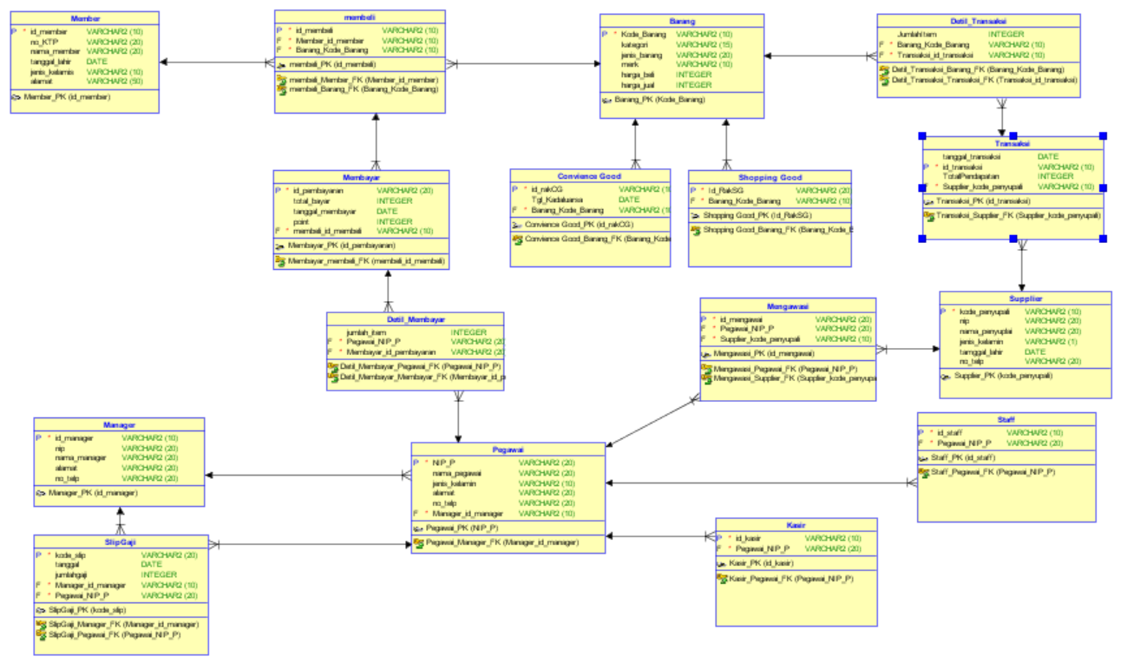

2.2 ERD

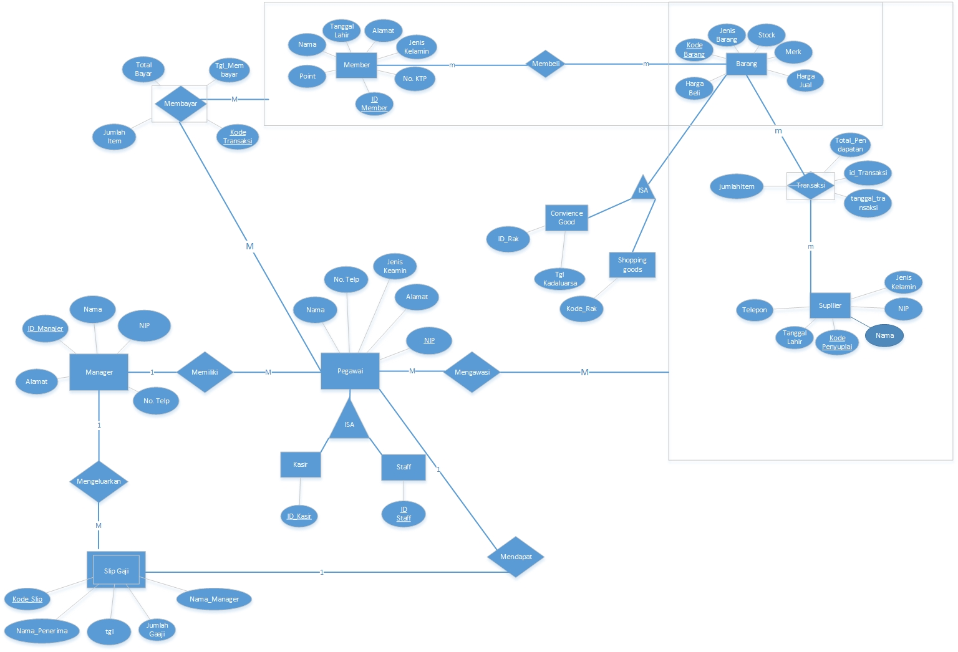

2.3 BUSSINESS CASE

Minimarket

Minimarket Devin, setiap harinya ramai di datangi pengunjung, banyak dari mereka yang menjadi member di Minimarket tersebut. Minimarket Devin memiliki banyak pegawai yang bertugas mengawasi pemasukkan barang barang di beberapa gudang di Minimarket tersebut. Produk di toko Devin dibagi menjadi beberapa jenis yaitu Shopping Good Product, product ini terdiri dari alat rumah tangga, baju, dan atk. Terdapat juga Convience Good Product, yang terdiri dari makanan, pasta gigi, baterai dll. Satu pelanggan dapat membeli banyak barang sesuai dengan kebutuhannya dan melakukan pembayaran di beberapa kasir. Seluruh barang yang dibeli akan dicatat dalam database, dan pembeli menerima nota pembelian. Devin berperan sebagai pengelola atas supermarketnya. Ia yang mengeluarkan slip gaji untuk para pegawainya setiap bulan.

Bussiness Rule:

1. Banyak Pembeli dapat mengambil banyak barang yang terbagi menjadi 2kategori yaitu Shopping Good Product, Convience Good
2. Beberapa Staff dapat mengawasi banyak supplier
3. Barang yang masuk disimpan kedalam gudang tertentu
4. Banyak Supplier yang dapat memasok beberapa barang sekaligus
5. Beberapa kasir dapat melakukan bayak transaksi dengan banyak pelanggan.
6. Setiap bulannya manager mengeluarkan slip gaji untuk para pegawainya.
7. Seorang pegawai hanya bisa mendapat 1 slip gaji.

2.4 DDL

CREATE TABLE Member (

id_member VARCHAR2 (10) NOT NULL ENABLE,

no_ktp VARCHAR2 (20),

nama_member VARCHAR2(20),

tanggal_lahir DATE,

alamat VARCHAR2 (50) ,

jenis_kelamin VARCHAR(10),

CONSTRAINT MEMBER_PK PRIMARY KEY (ID_MEMBER) ENABLE

) ;

CREATE TABLE Barang (

kode_barang VARCHAR2 (10) NOT NULL,

jenis_barang VARCHAR (20),

merk VARCHAR2 (10),

stock NUMBER,

harga_beli NUMBER,

harga_jual NUMBER,

CONSTRAINT BARANG_PK PRIMARY KEY (kode_barang) ENABLE

);

CREATE TABLE MEMBELI (

id_membeli VARCHAR (10) NOT NULL ENABLE,

kode_barang VARCHAR2 (10),

id_member VARCHAR2 (10),

CONSTRAINT MEMBELI_PK PRIMARY KEY (id_membeli) ENABLE,

CONSTRAINT KodeBarang_FK FOREIGN KEY (kode_barang)

REFERENCES BARANG (kode_barang) ON DELETE CASCADE ENABLE,

CONSTRAINT MEMBER_FK2 FOREIGN KEY (id_member)

REFERENCES MEMBER (id_member) ON DELETE CASCADE ENABLE

);

CREATE TABLE Supplier (

kode_penyuplai VARCHAR2 (10) NOT NULL,

nip VARCHAR2 (20),

nama_penyuplai VARCHAR2 (20),

jenis_kelamin VARCHAR2 (1),

tanggal_lahir DATE,

no_telp VARCHAR2 (20),

CONSTRAINT KODEPENYUPLAI_PK PMARY KEY (Kode_Penyuplai) ENABLE

);

CREATE TABLE GUDANG (

id_gudang VARCHAR2 (10) NOT NULL,

nama_gudang VARCHAR2(20),

CONSTRAINT idGudang_PK PRIMARY KEY (id_gudang) ENABLE

);

CREATE TABLE TRANSAKSI (

id_transaksi VARCHAR2 (10) NOT NULL,

Kode_penyuplai VARCHAR2 (10),

id_gudang VARCHAR2 (10),

tanggal_transaksi DATE,

TotalPendapatan NUMBER,

CONSTRAINT idTransaksi_PK PRIMARY KEY (id_transaksi) ENABLE,

CONSTRAINT KodePenyuplai_FK FOREIGN KEY (kode_penyuplai)

REFERENCES SUPPLIER ON DELETE CASCADE ENABLE,

CONSTRAINT idGudang_FK FOREIGN KEY (id_gudang)

REFERENCES GUDANG ON DELETE CASCADE ENABLE

);

CREATE TABLE DETIL_TRANSAKSI(

id_transaksi VARCHAR2 (10),

kode_barang VARCHAR2 (10),

jumlahItem NUMBER,

CONSTRAINT DETIL_TRANSAKSI_FK FOREIGN KEY (ID_TRANSAKSI)

REFERENCES TRANSAKSI (ID_TRANSAKSI) ON DELETE CASCADE ENABLE,

CONSTRAINT DETIL_TRANSAKSI_FK2 FOREIGN KEY (KODE_BARANG)

REFERENCES BARANG (KODE_BARANG) ON DELETE CASCADE ENABLE

);

CREATE TABLE Pegawai (

NIP_P VARCHAR2 (20) NOT NULL,

id_manager VARCHAR2 (10),

nama_pegawai VARCHAR2 (20),

jenis_kelamin VARCHAR2 (10),

alamat VARCHAR2 (20),

no_telp VARCHAR2 (20),

CONSTRAINT Pegawai_PK PRIMARY KEY (NIP_P) ENABLE,

CONSTRAINT idManager_FK FOREIGN KEY (id_manager)

REFERENCES Manager (id_manager) ON DELETE CASCADE ENABLE

);

CREATE TABLE MENGAWASI (

id_pengawasan VARCHAR2 (20) NOT NULL,

id_transaksi VARCHAR2 (10),

NIP_P VARCHAR2 (20),

CONSTRAINT Pengawasan_PK PRIMARY KEY (id_pengawasan) ENABLE,

CONSTRAINT idTransaksi_FK FOREIGN KEY (id_transaksi)

REFERENCES TRANSAKSI ON DELETE CASCADE ENABLE,

CONSTRAINT NIP_P_FK FOREIGN KEY (NIP_P)

REFERENCES PEGAWAI ON DELETE CASCADE ENABLE

);

CREATE TABLE MEMBAYAR (

id_pembayaran VARCHAR2 (20) NOT NULL,

id_membeli VARCHAR (10),

tanggal_membayar DATE,

total_bayar NUMBER,

point NUMBER,

CONSTRAINT idPembayaran_PK PRIMARY KEY (id_pembayaran) ENABLE,

CONSTRAINT idMembeli_FK FOREIGN KEY (id_membeli)

REFERENCES MEMBELI ON DELETE CASCADE ENABLE

);

CREATE TABLE DETIL_MEMBAYAR (

id_pembayaran VARCHAR2 (20),

NIP_P VARCHAR2 (20),

jumlah_item NUMBER,

CONSTRAINT idPembayaran_FK FOREIGN KEY (id_pembayaran)

REFERENCES MEMBAYAR ON DELETE CASCADE ENABLE,

CONSTRAINT NIP_FK FOREIGN KEY (NIP_P)

REFERENCES PEGAWAI ON DELETE CASCADE ENABLE

);

CREATE TABLE Manager (

id_manager VARCHAR2 (10) NOT NULL,

nip VARCHAR2 (20),

nama_manager VARCHAR2 (20),

alamat VARCHAR2 (20),

no_telp VARCHAR2 (20),

CONSTRAINT idManager_PK PRIMARY KEY (id_manager) ENABLE

);

CREATE TABLE SlipGaji (

kode_slip VARCHAR2 (20) NOT NULL,

NIP_P VARCHAR (20),

id_manager VARCHAR2 (10),

nama_penerima VARCHAR2 (20),

tanggal DATE,

jumlah_gaji NUMBER,

CONSTRAINT SlipGaji_PK PRIMARY KEY (kode_slip) ENABLE,

CONSTRAINT SlipGaji_FK1 FOREIGN KEY (id_manager)

REFERENCES MANAGER (id_manager) on delete cascade ENABLE,

CONSTRAINT SlipGaji_FK2 FOREIGN KEY (NIP_P)

REFERENCES PEGAWAI (NIP_P) on delete cascade ENABLE

);

alter session set nls_date_format= 'dd-mm-yyyy';

2.5 DML

INSERT INTO MEMBER VALUES('M001','00075002301','Della','20-02-1996','jl.sukapura 1','P');

INSERT INTO MEMBER VALUES('M002','00075002302','Ambar','11-05-1989','jl.sukabirus 2','P');

INSERT INTO MEMBER VALUES('M003','00075002303','Alvinda','02-07-1995','jl.sukabirus 3','P');

INSERT INTO MEMBER VALUES('M004','00075002304','Ferninda','14-04-1999','jl. Adhiyaksa 1','P');

INSERT INTO MEMBER VALUES('M005','00075002305','Gilda','17-08-1997','jl. lapten 1','P');

INSERT INTO MEMBER VALUES('M006','00075002306','Lula','13-09-1990','jl. Soeta','P');

INSERT INTO MEMBER VALUES('M007','00075002307','Gilang','20-12-1899','jl. BBC 1','L');

INSERT INTO MEMBER VALUES('M008','00075002308','Wira','15-11-1892','jl. mengger','L');

INSERT INTO MEMBER VALUES('M009','00075002309','Annas','02-10-1878','jl. mangga dua','L');

INSERT INTO MEMBER VALUES('M010','00075002310','Tama','15-10-1893','jl. Adhyaksa 2','L');

INSERT INTO MEMBER VALUES('M011','00075002311','Jaka','19-11-1895','Perum. Permata Buah Batu','L');

INSERT INTO MEMBER VALUES('M012','00075002312','Iday','18-09-1987','Ciganitri','L');

INSERT INTO MEMBER VALUES('M013','00075002313','Prana','23-01-1979','jl. mengger 3','L');

INSERT INTO MEMBER VALUES('M014','00075002314','Fandi','26-09-1971','jl. Umayyah','L');

INSERT INTO MEMBER VALUES('M015','00075002315','Fhadil','29-11-1895','Gang PGA','L');

INSERT INTO MEMBER VALUES('M016','00075002315','Novelly','01-01-1999','jl. mangga dua','P');

INSERT INTO MEMBER VALUES('M017','00075002315','Veshea','05-10-1997','jl. buahbatu','P');

INSERT INTO MEMBER VALUES('M018','00075002315','Aviani','25-08-1899','jl. lapten 2','P');

INSERT INTO MEMBER VALUES('M019','00075002315','Ary','19-02-1993','Gang PGA','L');

INSERT INTO MEMBER VALUES('M020','00075002315','Pras','24-11-1892','Gang ABC','L');

INSERT INTO BARANG VALUES('BRG001','FOOD','Snack','Oreo',2500,1000,2000);

INSERT INTO BARANG VALUES('BRG002','NON-FOOD','Sabun','Lux',600,2000,3500);

INSERT INTO BARANG VALUES('BRG003','NON-FOOD','Pasta Gigi','Pepsodent',500,10000,15000);

INSERT INTO BARANG VALUES('BRG004','NON-FOOD','Alat Cukur','Gillete',1000,4500,7000);

INSERT INTO BARANG VALUES('BRG005','FOOD','Minuman','Green Tea',500,2000,5000);

INSERT INTO BARANG VALUES('BRG006','NON-FOOD','Perkakas','Sapu','100',20000,30000);

INSERT INTO BARANG VALUES('BRG007','FOOD','Nugget','Belfood',200,15000,20000);

INSERT INTO BARANG VALUES('BRG008','FOOD','Sosis','Fiesta',250,18000,25000);

INSERT INTO BARANG VALUES('BRG009','FOOD','Snack','Chitato',1250,5000,9000);

INSERT INTO BARANG VALUES('BRG010','NON-FOOD','Detergen','Rinso',600,14000,22000);

INSERT INTO BARANG VALUES('BRG011','NON-FOOD','Mainan','Hot Wheels',500,15000,29000);

INSERT INTO BARANG VALUES('BRG012','FOOD','Roti','BreadLlife',100,2000,3500);

INSERT INTO BARANG VALUES('BRG013','FOOD','Sosis','So Nice',200,20000,30000);

INSERT INTO BARANG VALUES('BRG014','FOOD','Biskuit','Nissin',70,7000,10000);

INSERT INTO BARANG VALUES('BRG015','FOOD','Wafer','Tango',100,9000,14000);

INSERT INTO BARANG VALUES('BRG016','NON-FOOD','Masker Wajah','Olay',300,2000,5000);

INSERT INTO BARANG VALUES('BRG017','NON-FOOD','Sabun','Lifebouy',400,20000,31000);

INSERT INTO BARANG VALUES('BRG018','NON-FOOD','Shampoo','Tresemme',200,30000,40000);

INSERT INTO BARANG VALUES('BRG019','FOOD','Minuman','Oolong Tea',200,3000,7000);

INSERT INTO BARANG VALUES('BRG020','FOOD','Roti','Sari Roti',70,4000,5000);

INSERT INTO MEMBELI VALUES('MBL001','BRG001','M002');

INSERT INTO MEMBELI VALUES('MBL002','BRG003','M003');

INSERT INTO MEMBELI VALUES('MBL003','BRG004','M009');

INSERT INTO MEMBELI VALUES('MBL004','BRG004','M010');

INSERT INTO MEMBELI VALUES('MBL005','BRG003','M009');

INSERT INTO MEMBELI VALUES('MBL006','BRG011','M001');

INSERT INTO MEMBELI VALUES('MBL007','BRG012','M005');

INSERT INTO MEMBELI VALUES('MBL008','BRG019','M007');

INSERT INTO MEMBELI VALUES('MBL009','BRG020','M002');

INSERT INTO MEMBELI VALUES('MBL010','BRG020','M017');

INSERT INTO MEMBELI VALUES('MBL011','BRG001','M018');

INSERT INTO MEMBELI VALUES('MBL012','BRG003','M008');

INSERT INTO MEMBELI VALUES('MBL013','BRG005','M020');

INSERT INTO MEMBELI VALUES('MBL014','BRG007','M016');

INSERT INTO MEMBELI VALUES('MBL015','BRG008','M018');

INSERT INTO MEMBELI VALUES('MBL016','BRG008','M008');

INSERT INTO MEMBELI VALUES('MBL017','BRG010','M007');

INSERT INTO MEMBELI VALUES('MBL018','BRG011','M014');

INSERT INTO MEMBELI VALUES('MBL019','BRG019','M013');

INSERT INTO MEMBELI VALUES('MBL020','BRG018','M017');

INSERT INTO SUPPLIER VALUES('SPL001','190900001','Agus','L','12-02-1980','081340920901');

INSERT INTO SUPPLIER VALUES('SPL002','190900002','Sita','P','19-10-1984','081340921254');

INSERT INTO SUPPLIER VALUES('SPL003','190900003','Iqbal','L','21-09-1989','081340920987');

INSERT INTO SUPPLIER VALUES('SPL004','190900004','Juki','L','13-10-1990','081340920721');

INSERT INTO SUPPLIER VALUES('SPL005','190900005','Fachri','L','15-11-1991','081340925789');

INSERT INTO SUPPLIER VALUES('SPL006','190900006','Annisa','P','20-10-1993','081340920938');

INSERT INTO SUPPLIER VALUES('SPL007','190900007','Reyhan','L','11-03-1989','081340921938');

INSERT INTO SUPPLIER VALUES('SPL008','190900008','Yoranda','P','21-11-1982','081340921254');

INSERT INTO SUPPLIER VALUES('SPL009','190900009','Kiki','L','23-08-1987','081340928032');

INSERT INTO SUPPLIER VALUES('SPL010','190900010','Fila','P','10-02-1989','081340925762');

INSERT INTO SUPPLIER VALUES('SPL011','190900011','Ijat','L','15-04-1993','081340929810');

INSERT INTO SUPPLIER VALUES('SPL012','190900012','Dikka','L','28-07-1990','081340924209');

INSERT INTO SUPPLIER VALUES('SPL013','190900013','Farid','L','23-07-1991','081340926410');

INSERT INTO SUPPLIER VALUES('SPL014','190900014','Reza','L','21-11-1980','081340921938');

INSERT INTO SUPPLIER VALUES('SPL015','190900015','Dhea','P','24-01-1979','081340921930');

INSERT INTO SUPPLIER VALUES('SPL016','190900016','Khansa','P','14-12-1983','081340922183');

INSERT INTO SUPPLIER VALUES('SPL017','190900017','Boy','L','19-11-1991','081340924353');

INSERT INTO SUPPLIER VALUES('SPL018','190900018','Adhi','L','01-05-1996','081340924892');

INSERT INTO SUPPLIER VALUES('SPL019','190900019','Sindy','P','16-04-1980','081340920293');

INSERT INTO SUPPLIER VALUES('SPL020','190900020','Saleh','L','19-08-1987','081340922093');

INSERT INTO MANAGER VALUES('MNG0001','23909876','Devin','Jl.Soeta','081323338999');

INSERT INTO PEGAWAI VALUES('3401901','MNG0001','Mince','L','Desa Sukalenyap','081234094738');

INSERT INTO PEGAWAI VALUES('3401902','MNG0001','Aldi','L','Sukabirus Street','081234603918');

INSERT INTO PEGAWAI VALUES('3401903','MNG0001','Rena','P','Jl. Sukapura','081234098376');

INSERT INTO PEGAWAI VALUES('3401904','MNG0001','Annisa','P','Palasari street','081234123456');

INSERT INTO PEGAWAI VALUES('3401905','MNG0001','Michael','L','Jl.menteng','081234234567');

INSERT INTO PEGAWAI VALUES('3401906','MNG0001','Anji','L','Jl.Kenangan 2','081234345678');

INSERT INTO PEGAWAI VALUES('3401907','MNG0001','Ery','P','Jl.Terlupakan','081234456789');

INSERT INTO PEGAWAI VALUES('3401908','MNG0001','Dino','L','Jl.Sukapura 2','081234567891');

INSERT INTO PEGAWAI VALUES('3401909','MNG0001','Faras','L','Jl.raya soeka','081234789234');

INSERT INTO PEGAWAI VALUES('3401910','MNG0001','Said','L','Jl. PGA 2','081234182930');

INSERT INTO PEGAWAI VALUES('3401911','MNG0001','Lia','P','Jl. Ummayah','081234567483');

INSERT INTO PEGAWAI VALUES('3401912','MNG0001','Dini','P','Jl. radio','081234128765');

INSERT INTO PEGAWAI VALUES('3401913','MNG0001','Rita','P','Jl. soeta 2','081234567123');

INSERT INTO PEGAWAI VALUES('3401914','MNG0001','Fawaz','L','Jl. delima 2','081234098765');

INSERT INTO PEGAWAI VALUES('3401915','MNG0001','Riko','L','Jl. Apel fuji','081234125623');

INSERT INTO PEGAWAI VALUES('3401916','MNG0001','Imran','L','Jl. Anggrek 5','081234456123');

INSERT INTO PEGAWAI VALUES('3401917','MNG0001','Ikhsan','P','Jl. Adonis 2','081234098237');

INSERT INTO PEGAWAI VALUES('3401918','MNG0001','Lisa','P','Jl. Mawar 2','081234678123');

INSERT INTO PEGAWAI VALUES('3401919','MNG0001','Ricky','L','Jl. Melati 1','081234789093');

INSERT INTO PEGAWAI VALUES('3401920','MNG0001','Andini','P','Jl. Sukareus','081234179167');

INSERT INTO SlipGaji VALUES('SLGJ0001','3401901','MNG0001','27-01-2017',1500000);

INSERT INTO SlipGaji VALUES('SLGJ0002','3401901','MNG0001','27-02-2017',1750000);

INSERT INTO SlipGaji VALUES('SLGJ0003','3401902','MNG0001','27-01-2017',1500000);

INSERT INTO SlipGaji VALUES('SLGJ0004','3401908','MNG0001','27-01-2017',1500000);

INSERT INTO SlipGaji VALUES('SLGJ0005','3401909','MNG0001','27-01-2017',1500000);

INSERT INTO SlipGaji VALUES('SLGJ0006','3401911','MNG0001','27-01-2017',1500000);

INSERT INTO SlipGaji VALUES('SLGJ0007','3401907','MNG0001','27-01-2017',1500000);

INSERT INTO SlipGaji VALUES('SLGJ0008','3401909','MNG0001','27-02-2017',1750000);

INSERT INTO SlipGaji VALUES('SLGJ0009','3401909','MNG0001','27-03-2017',1800000);

INSERT INTO SlipGaji VALUES('SLGJ0010','3401902','MNG0001','27-02-2017',1500000);

INSERT INTO SlipGaji VALUES('SLGJ0011','3401903','MNG0001','27-01-2017',1500000);

INSERT INTO SlipGaji VALUES('SLGJ0012','3401904','MNG0001','27-01-2017',1500000);

INSERT INTO SlipGaji VALUES('SLGJ0013','3401917','MNG0001','27-01-2017',1500000);

INSERT INTO SlipGaji VALUES('SLGJ0014','3401916','MNG0001','27-01-2017',1500000);

INSERT INTO SlipGaji VALUES('SLGJ0015','3401915','MNG0001','27-01-2017',1500000);

INSERT INTO SlipGaji VALUES('SLGJ0016','3401916','MNG0001','27-02-2017',1750000);

INSERT INTO SlipGaji VALUES('SLGJ0017','3401917','MNG0001','27-02-2017',1750000);

INSERT INTO SlipGaji VALUES('SLGJ0018','3401919','MNG0001','27-01-2017',1500000);

INSERT INTO SlipGaji VALUES('SLGJ0019','3401918','MNG0001','27-01-2017',1500000);

INSERT INTO SlipGaji VALUES('SLGJ0020','3401920','MNG0001','27-01-2017',1500000);

INSERT INTO DETIL_TRANSAKSI VALUES('TRX0001','BRG002',200);

INSERT INTO DETIL_TRANSAKSI VALUES('TRX0002','BRG003',100);

INSERT INTO DETIL_TRANSAKSI VALUES('TRX0003','BRG006',20);

INSERT INTO DETIL_TRANSAKSI VALUES('TRX0004','BRG001',700);

INSERT INTO DETIL_TRANSAKSI VALUES('TRX0005','BRG016',70);

INSERT INTO DETIL_TRANSAKSI VALUES('TRX0006','BRG010',200);

INSERT INTO DETIL_TRANSAKSI VALUES('TRX0007','BRG018',100);

INSERT INTO DETIL_TRANSAKSI VALUES('TRX0008','BRG009',1000);

INSERT INTO DETIL_TRANSAKSI VALUES('TRX0009','BRG005',200);

INSERT INTO DETIL_TRANSAKSI VALUES('TRX0010','BRG011',250);

INSERT INTO DETIL_TRANSAKSI VALUES('TRX0011','BRG012',20);

INSERT INTO DETIL_TRANSAKSI VALUES('TRX0012','BRG013',100);

INSERT INTO DETIL_TRANSAKSI VALUES('TRX0013','BRG008',300);

INSERT INTO DETIL_TRANSAKSI VALUES('TRX0014','BRG014',30);

INSERT INTO DETIL_TRANSAKSI VALUES('TRX0015','BRG004',500);

INSERT INTO DETIL_TRANSAKSI VALUES('TRX0016','BRG017',200);

INSERT INTO DETIL_TRANSAKSI VALUES('TRX0017','BRG015',50);

INSERT INTO DETIL_TRANSAKSI VALUES('TRX0018','BRG007',200);

INSERT INTO DETIL_TRANSAKSI VALUES('TRX0019','BRG019',100);

INSERT INTO DETIL_TRANSAKSI VALUES('TRX0020','BRG020',20);

INSERT INTO TRANSAKSI VALUES('TRX0001','SPL005','10-02-2017',400000);

INSERT INTO TRANSAKSI VALUES('TRX0002','SPL006','15-02-2017',1000000);

INSERT INTO TRANSAKSI VALUES('TRX0003','SPL001','21-03-2017',400000);

INSERT INTO TRANSAKSI VALUES('TRX0004','SPL002','10-03-2017',700000);

INSERT INTO TRANSAKSI VALUES('TRX0005','SPL012','15-03-2017',140000);

INSERT INTO TRANSAKSI VALUES('TRX0006','SPL010','23-03-2017',2800000);

INSERT INTO TRANSAKSI VALUES('TRX0007','SPL015','09-04-2017',3000000);

INSERT INTO TRANSAKSI VALUES('TRX0008','SPL007','11-04-2017',5000000);

INSERT INTO TRANSAKSI VALUES('TRX0009','SPL001','21-04-2017',400000);

INSERT INTO TRANSAKSI VALUES('TRX0010','SPL013','25-04-2017',3750000);

INSERT INTO TRANSAKSI VALUES('TRX0011','SPL011','11-05-2017',40000);

INSERT INTO TRANSAKSI VALUES('TRX0012','SPL015','21-05-2017',2000000);

INSERT INTO TRANSAKSI VALUES('TRX0013','SPL010','22-05-2017',5400000);

INSERT INTO TRANSAKSI VALUES('TRX0014','SPL002','30-15-2017',210000);

INSERT INTO TRANSAKSI VALUES('TRX0015','SPL009','02-06-2017',2250000);

INSERT INTO TRANSAKSI VALUES('TRX0016','SPL013','08-07-2017',4000000);

INSERT INTO TRANSAKSI VALUES('TRX0017','SPL015','12-08-2017',450000);

INSERT INTO TRANSAKSI VALUES('TRX0018','SPL017','19-08-2017',3000000);

INSERT INTO TRANSAKSI VALUES('TRX0019','SPL003','20-10-2017',300000);

INSERT INTO TRANSAKSI VALUES('TRX0020','SPL020','25-12-2017',80000);

INSERT INTO MENGAWASI VALUES('PGWSN001','TRX0001','3401905');

INSERT INTO MENGAWASI VALUES('PGWSN002','TRX0002','3401906');

INSERT INTO MENGAWASI VALUES('PGWSN003','TRX0003','3401908');

INSERT INTO MENGAWASI VALUES('PGWSN004','TRX0004','3401910');

INSERT INTO MENGAWASI VALUES('PGWSN005','TRX0005','3401909');

INSERT INTO MENGAWASI VALUES('PGWSN006','TRX0006','3401907');

INSERT INTO MENGAWASI VALUES('PGWSN007','TRX0007','3401911');

INSERT INTO MENGAWASI VALUES('PGWSN008','TRX0008','3401912');

INSERT INTO MENGAWASI VALUES('PGWSN009','TRX0009','3401914');

INSERT INTO MENGAWASI VALUES('PGWSN010','TRX0010','3401915');

INSERT INTO MENGAWASI VALUES('PGWSN011','TRX0011','3401913');

INSERT INTO MENGAWASI VALUES('PGWSN012','TRX0012','3401905');

INSERT INTO MENGAWASI VALUES('PGWSN013','TRX0013','3401906');

INSERT INTO MENGAWASI VALUES('PGWSN014','TRX0014','3401909');

INSERT INTO MENGAWASI VALUES('PGWSN015','TRX0015','3401908');

INSERT INTO MENGAWASI VALUES('PGWSN016','TRX0016','3401910');

INSERT INTO MENGAWASI VALUES('PGWSN017','TRX0017','3401907');

INSERT INTO MENGAWASI VALUES('PGWSN018','TRX0018','3401912');

INSERT INTO MENGAWASI VALUES('PGWSN019','TRX0019','3401913');

INSERT INTO MENGAWASI VALUES('PGWSN020','TRX0020','3401914');

INSERT INTO MEMBAYAR VALUES('PMBYR001','MBL002','10-02-2017',500000,50);

INSERT INTO MEMBAYAR VALUES('PMBYR002','MBL003','15-02-2017',420000,42);

INSERT INTO MEMBAYAR VALUES('PMBYR003','MBL004','21-02-2017',320000,32);

INSERT INTO MEMBAYAR VALUES('PMBYR004','MBL002','10-03-2017',780000,78);

INSERT INTO MEMBAYAR VALUES('PMBYR005','MBL014','15-03-2017',1000000,100);

INSERT INTO MEMBAYAR VALUES('PMBYR006','MBL005','23-04-2017',120000,12);

INSERT INTO MEMBAYAR VALUES('PMBYR007','MBL002','09-04-2017',500000,50);

INSERT INTO MEMBAYAR VALUES('PMBYR008','MBL001','11-05-2017',300000,30);

INSERT INTO MEMBAYAR VALUES('PMBYR009','MBL014','21-05-2017',800000,80);

INSERT INTO MEMBAYAR VALUES('PMBYR010','MBL005','25-05-2017',375000,37);

INSERT INTO MEMBAYAR VALUES('PMBYR011','MBL010','11-05-2017',98000,9);

INSERT INTO MEMBAYAR VALUES('PMBYR012','MBL011','21-06-2017',200000,20);

INSERT INTO MEMBAYAR VALUES('PMBYR013','MBL018','22-07-2017',560000,56);

INSERT INTO MEMBAYAR VALUES('PMBYR014','MBL013','30-08-2017',220000,22);

INSERT INTO MEMBAYAR VALUES('PMBYR015','MBL016','02-09-2017',230000,23);

INSERT INTO MEMBAYAR VALUES('PMBYR016','MBL017','08-09-2017',578000,57);

INSERT INTO MEMBAYAR VALUES('PMBYR017','MBL018','12-09-2017',91000,9);

INSERT INTO MEMBAYAR VALUES('PMBYR018','MBL019','19-09-2017',450000,45);

INSERT INTO MEMBAYAR VALUES('PMBYR019','MBL020','20-10-2017',78000,7);

INSERT INTO MEMBAYAR VALUES('PMBYR020','MBL006','25-10-2017',12000,1);

INSERT INTO DETIL_MEMBAYAR VALUES('PMBYR001','3401901',9);

INSERT INTO DETIL_MEMBAYAR VALUES('PMBYR002','3401903',10);

INSERT INTO DETIL_MEMBAYAR VALUES('PMBYR003','3401904',2);

INSERT INTO DETIL_MEMBAYAR VALUES('PMBYR004','3401902',7);

INSERT INTO DETIL_MEMBAYAR VALUES('PMBYR005','3401916',9);

INSERT INTO DETIL_MEMBAYAR VALUES('PMBYR006','3401918',2);

INSERT INTO DETIL_MEMBAYAR VALUES('PMBYR007','3401919',9);

INSERT INTO DETIL_MEMBAYAR VALUES('PMBYR008','3401920',10);

INSERT INTO DETIL_MEMBAYAR VALUES('PMBYR009','3401903',8);

INSERT INTO DETIL_MEMBAYAR VALUES('PMBYR010','3401902',5);

INSERT INTO DETIL_MEMBAYAR VALUES('PMBYR011','3401901',8);

INSERT INTO DETIL_MEMBAYAR VALUES('PMBYR012','3401904',4);

INSERT INTO DETIL_MEMBAYAR VALUES('PMBYR013','3401917',5);

INSERT INTO DETIL_MEMBAYAR VALUES('PMBYR014','3401904',7);

INSERT INTO DETIL_MEMBAYAR VALUES('PMBYR015','3401903',9);

INSERT INTO DETIL_MEMBAYAR VALUES('PMBYR016','3401901',12);

INSERT INTO DETIL_MEMBAYAR VALUES('PMBYR017','3401917',7);

INSERT INTO DETIL_MEMBAYAR VALUES('PMBYR018','3401908',3);

INSERT INTO DETIL_MEMBAYAR VALUES('PMBYR019','3401901',8);

INSERT INTO DETIL_MEMBAYAR VALUES('PMBYR020','3401903',4);2.6

2.6 QUERY

1. Menampilkan Nama_Member, ID_Pembayaran, dan Total point pelanggan yang lebih dari 50

select member.nama_member, membayar.id_pembayaran, SUM(POINT) "POINT"

FROM MEMBER

JOIN MEMBELI ON MEMBELI.ID_MEMBER = MEMBER.ID_MEMBER

JOIN MEMBAYAR ON MEMBAYAR.ID_MEMBELI = MEMBELI.ID_MEMBELI

JOIN DETIL_MEMBAYAR ON DETIL_MEMBAYAR.ID_PEMBAYARAN = MEMBAYAR.ID_PEMBAYARAN

WHERE POINT >= 50

GROUP BY member.nama_member, MEMBAYAR.ID_PEMBAYARAN;

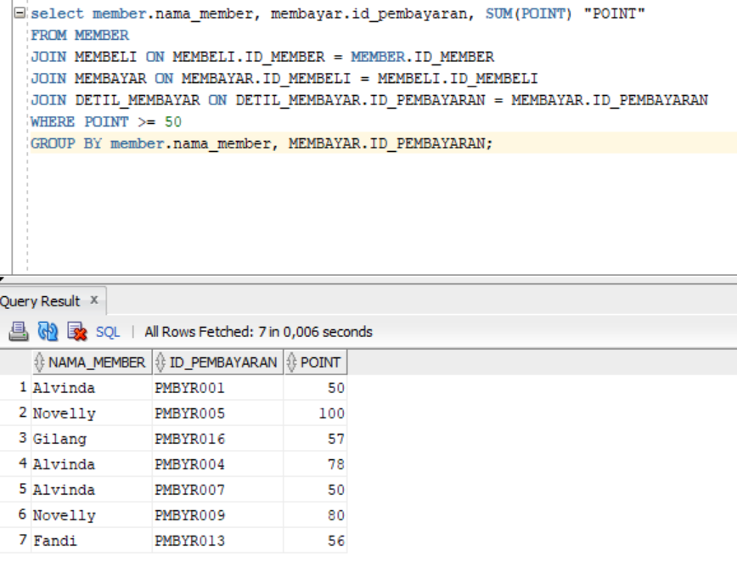

1. Menampilkan Nama Supplier, Kode Supplier, dan Total Pendapatannya dari penyuplaian di Minimarket Devin

select SUPPLIER.NAMA_PENYUPLAI, SUPPLIER.KODE_PENYUPLAI, SUM(TRANSAKSI.TOTALPENGELUARAN) AS PENDAPATAN_SUPPLIER

FROM SUPPLIER, PEGAWAI, MENGAWASI, TRANSAKSI

WHERE SUPPLIER.KODE_PENYUPLAI = TRANSAKSI.KODE_PENYUPLAI

AND TRANSAKSI.ID_TRANSAKSI = MENGAWASI.ID_TRANSAKSI

AND PEGAWAI.NIP_P = MENGAWASI.NIP_P

group by SUPPLIER.NAMA_PENYUPLAI, SUPPLIER.KODE_PENYUPLAI;

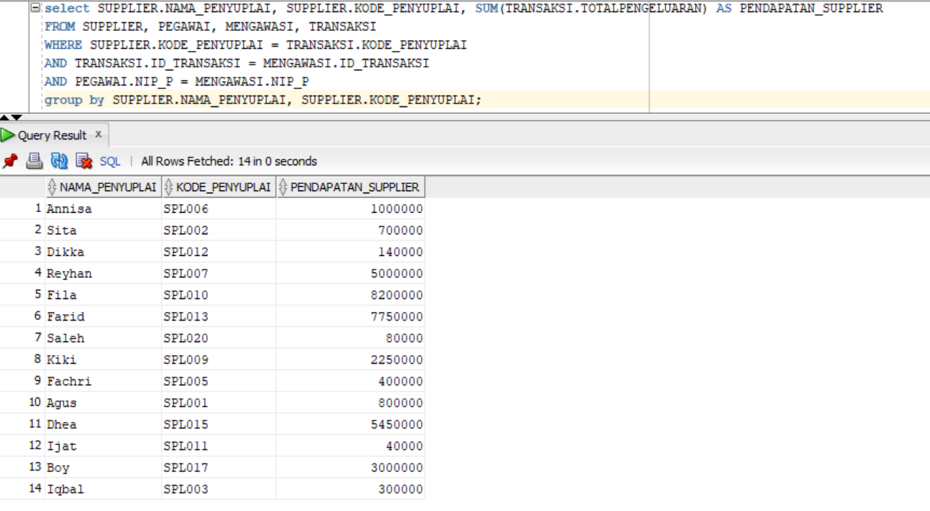

1. Menampilkan, Id Member, nama member yang paling boros, dan total pengeluaran dari transaksi yang dilakukan.

select * from

(select round(sum(mm.total_bayar)) "Total Bayar", mb.id_member "ID Member", m.nama_member

from membayar mm, membeli mb, member m

where mm.id_membeli = mb.id_membeli

and m.ID_MEMBER = mb.ID_MEMBER

group by mb.id_member, m.nama_member

order by sum(mm.total_bayar) desc

)

where rownum = 1;

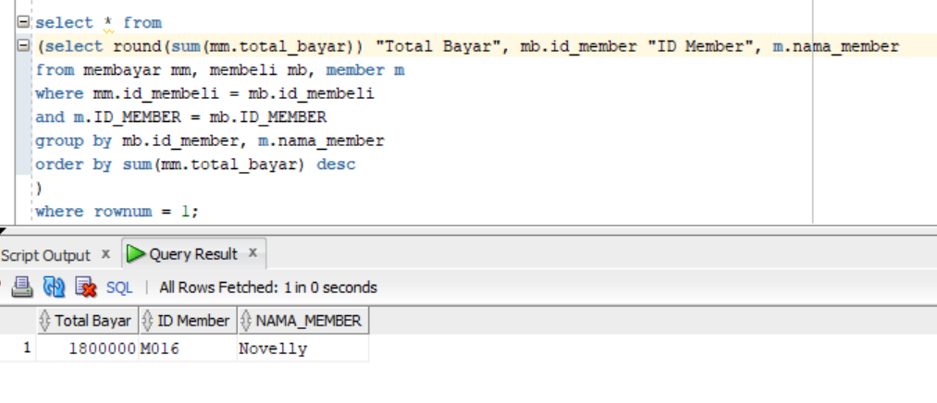

1. Menampilkan nama kasir, nip, nama member yang dilayani pada suatu tanggal.

select NAMA_PEGAWAI "NAMA KASIR", NIP_P, NAMA_MEMBER, TANGGAL_MEMBAYAR

FROM MEMBER

JOIN MEMBELI USING (ID_MEMBER)

JOIN MEMBAYAR USING (ID_MEMBELI)

JOIN DETIL_MEMBAYAR USING (ID_PEMBAYARAN)

JOIN PEGAWAI USING (NIP_P);

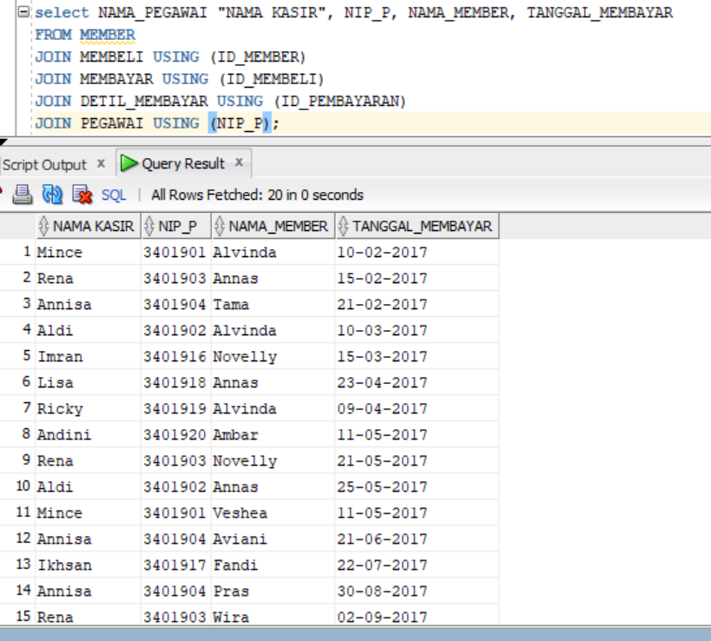

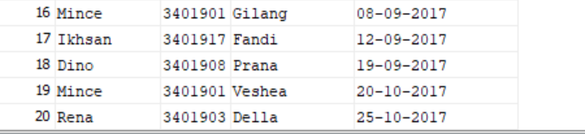

1. Menampilkan umur member

select nama_member, jenis_kelamin, alamat, ceil((sysdate-tanggal_lahir)/365) as UMUR

From member

where ceil((sysdate-tanggal_lahir)/365)<100;

